Refrigeration Equipment Preventative Maintenance Services RFP
Questions and answers

Question: The pricing that we provide for PM is for the PM specifically and any part or repair we notice would be quoted out. So, we just want to confirm that there would be an additional charge for parts and labor to make repairs as we would have no way of predicting what may be needed for parts in the future. Can you please clarify what is meant by the highlighted section below. Thanks for any insight.

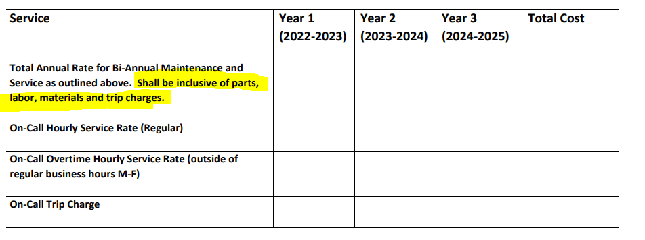

Answer: The requirements of the annual service are noted in Attachment A. Should parts (ie filters) be required as part of that annual service those parts should be included in your annual service pricing. For on-call repairs, parts would naturally be priced out and quoted separately as part of the on call service event as those are outside of the annual PM service contract.

